**Name**:___________________________ **Date**:______________

**Year & Block**: _____________________ **Score**: ______________

**Laboratory Activity 1**

**Problem: Online Learning Platform**

* Create an abstract class Course with attributes: title, instructor.
* Define an abstract method enrollStudent() (no body).
* Define a method courseDetails() (with body) that prints the course title and instructor.
* Create two subclasses:
  1. ProgrammingCourse has language (PHP) and implements enrollStudent().
  2. DesignCourse → has software (Figma) and implements enrollStudent().
* In the main program:
  1. Ask the user to input their name.
  2. Create one object of ProgrammingCourse and one object of DesignCourse.
  3. Call courseDetails() for each course.
  4. Enroll the student (using the name they entered) in both courses by calling enrollStudent().

**Sample Output**

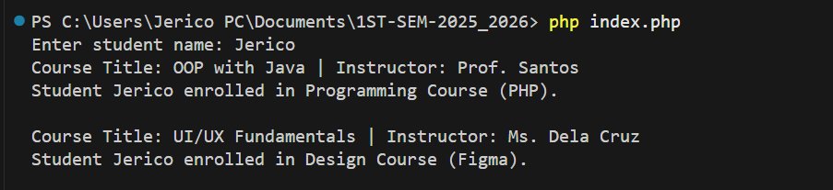

|  |
| --- |
| // Screenshot of your code |

| **Criteria** | **Points** |
| --- | --- |
| Complete solution (all requirements met) | 50 pts |
| Partial solution (some requirements met) | 30 pts |
| Incomplete / very minimal solution | 10 pts |
| **Total:** |  |